Part 3 Enduring Issue
Document 1
In the south of France there is a taille [tax on the land and its produce]. There is an injustice in levying the amount each person must pay. Lands held by the nobility are taxed very little. Lands held by commoners are taxed heavily… September 5, 1788: The poor people seem very poor indeed. The children are terribly ragged. June 10, 1789: The lack of bread is terrible. Stories arrive every moment from the provinces of riots and disturbances, and calling in the military, to preserve the peace of the markets….The price of bread has risen above people’s ability to pay. This causes great misery. July 1789: ….I was joined by a poor woman who complained of the hard times. “The tailles and feudal dues [rents owed the lords] are crushing us,” she said.
Source: This excerpt is adapted from Travels in France by Arthur Young, who traveled through France from 1787 to 1789.
Document 2
“ In May 1802, Napoleon’s forces tried to re-establish slavery. To make matters worse, the French Commander kidnapped Toussaint and deported him back to France. The effect was to enrage the black majority and provoke an even greater rebellion. By now black soldiers had gained experience in organizing an army. The French were at a disadvantage” they were more susceptible to disease (particularly yellow fever) than their opponents, and reinforcements were difficult to obtain from France. The French troops were also demoralized by fighting against enemies who sang the Marsellaise and invoked revolutionary ideals. One officer, Lacroix, asked, “Have our barbarous enemies justice on their side? Are we no longer the soldiers of Republican France? And have we become crude instruments of policy?”
Source: Mark Almond, 20th century historian Revolution 500 Years of struggle for Change p. 85
Document 3
Jamaica Letter (Carte de Jamaica), Simón Bolívar (1815)
In 1815, when in Jamaica and trying to raise money for the Venezuelan fight for independence from Spain, Simon Bolívar wrote this letter in which he writes about his hopes for an independent and unified South America.
My dear Sir:
...The chains have been broken; we have been freed, and now our enemies seek to enslave us anew. For this reason (South) America fights desperately...
[...]
The role of the inhabitants of the American hemisphere has for centuries been purely passive. Politically they were nonexistent. We are still in a position lower than slavery, and therefore it is more difficult for us to rise to the enjoyment of freedom … a people is therefore enslaved when the government, by its nature or its vices, infringes on and usurps [takes away] the rights of the citizen or subject....Under absolutism there are no recognized limits to the exercise of governmental powers.
[...]
So negative was our existence that I can find nothing comparable in any other civilized society, examine as I may the entire history of time and the politics of all nations. Is it not an outrage and a violation of human rights to expect a land so splendidly endowed, so vast, rich, and populous, to remain merely passive?
Source: Simón Bolívar (1815), Jamaica Letter (Carte de Jamaica), http://faculty.smu.edu/bakewell/BAKEWELL/texts/jamaica-letter.htm

Document 4
For two years, starting in December, 2010, protest movements throughout the Middle East and Northern and Western Africa broke out in predominantly Muslim countries controlled by authoritarian governments ruled by people with absolute power.  Though the specific demands of the protestors were different in each country, most wanted economic opportunities, political and civil rights, and democratically elected officials.  One of the largest protests took place in Egypt and was centered in Tahrir Square. | 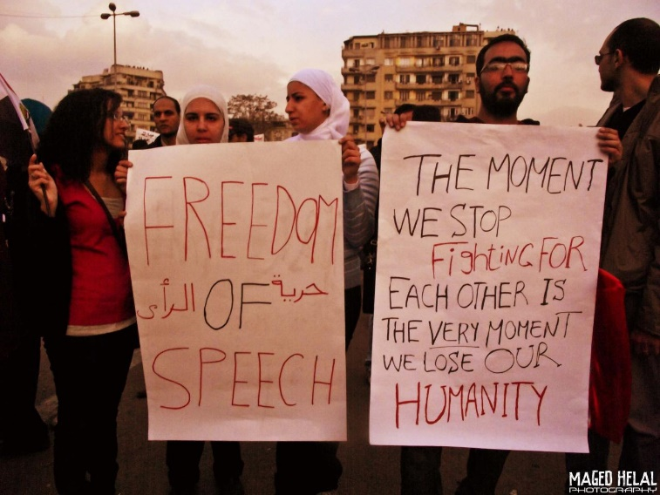  Protesters holding signs at the Tahrir Square Protests in 2011 that say “Freedom of Speech” and “The Moment We Stop Fighting For Each Other is the Very Moment We Lose Our Humanity.”  Photo was taken by Maged Helal and is published under the Creative Commons 2.0 Generic license.
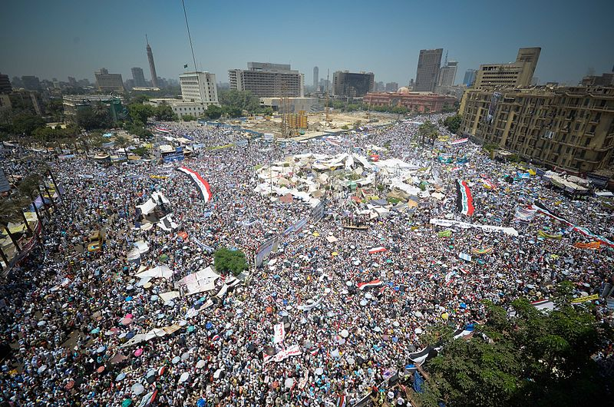
Tahrir Square, Egypt on July 29, 2011.
Image created by Ahmed Abd El-Fatah and is licensed under the Creative CommonsAttribution 2.0 Generic license.

